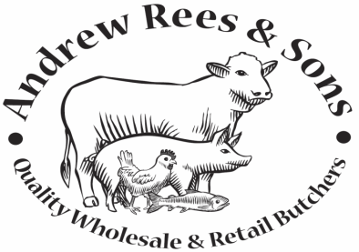
Retail Shop: 29 High Street, Narberth, Pembrokeshire. Tel: 01834 861892
Catering: Units 3&4, West Wales Business Park, Narberth, Pembrokeshire. Tel: 01834 860470

Modern Slavery Statement

Modern Slavery Act 2015

Structure, business and supply chain
A.J. Rees & Son’s Ltd is an award winning local butcher and wholesaler based in Narberth.
The company supplies quality locally sourced and fully traceable meat products from its catering unit in Narberth to over 300 businesses large and small, including; Restaurants, Hotels, Theme Parks, Pubs, Nursing Homes, Guest Houses and Schools throughout Pembrokeshire, Ceredigion and West Carmarthenshire, thus contributing and supporting both local farmers and the local tourist industry in general.
The retail shop is a favourite for local residents and tourists alike, it not only provides quality local meats, but also a large variety of own recipe sausages, burgers and cooked meats and a range of home-cooked pies and pasties. All highly commended by their customers.
A.J. Rees & Son’s Ltd is aware of its social responsibility and we believe transparency is the best way we can ensure the public that we are doing our best as an ethical business. In that spirit, we have published our annual statement for slavery and human trafficking, made in compliance with section 54 of the Modern Slavery Act 2015, in which we explain how slavery and human trafficking can affect our business and the steps we are taking in the fight against it. This statement is intended to fulfil the legal requirement for a slavery and human trafficking statement. A.J. Rees & Son’s Ltd is fully committed to ethical working practices and regards inhuman conditions such as slavery, worker exploitation and human trafficking as completely unacceptable within our business or our supply chain.
We have over 20 local employees in our business.
Building on our commitment to the Ethical Trading Initiative, we have embraced the requirement to publish an annual slavery and human trafficking statement. This will allow us to share our efforts against slavery and human trafficking. This year in February 2017, we took the following key steps to ensure slavery and human trafficking does not occur within our company or supply chain.

Our Supply Chains
The majority of the company’s suppliers are based in the United Kingdom and regulated by UK legislation in regards to their working procedures, including Health & Safety at work, working time regulations, equality and compliance with Human Rights regulations. All other Suppliers are based in Europe and have to comply with the EU law.

Slavery and human trafficking policy
We intend to take the following steps to combat slavery and human trafficking:
• Undertake a review of the effectiveness of our supply chain controls in reducing the risk of unethical practices
• Relationships: Strengthening our supplier engagement process
• Feedback: Establishing grievance mechanisms and channels for individual worker feedback
• Knowledge: Improving our knowledge base by collecting relevant data and launch training for managing staff

Due diligence procedures
We understand that our biggest exposure to Modern Slavery is in our product supply chains. Within these areas, new suppliers and factories/sites are subject to due diligence checks. If issues are identified through our supplier assessment questionnaire appropriate investigative and remedial actions will be taken.

Identifying, assessing and managing risk
We set out to identify the extent of any slavery and human trafficking in our supply chains by:
• ensuring all staff are made aware of our staff complaints policy. Any colleague who has concerns about any aspect of the business is able to disclose their concerns in accordance with the policy.
• Instituting an annual review questionnaire for existing suppliers.

Key performance indicators
In order to assess the effectiveness of our modern slavery measures we will be reviewing the following key performance indicators:
• Staff training levels
• Number of slavery incidents reported in the supply chain

Training available to staff
A key part of our slavery and human trafficking strategy is to promote cultural change through training.
• online training modules on modern slavery to all staff
• make all staff aware of slavery and human trafficking and workers’ rights

Date: 29/03/2017 Reviewed: 20/01/2023
Date for review: 20/01/2023
Signed: 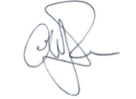
Andrew Rees Managing Director

This statement is made pursuant to section 54(1) of the Modern Slavery Act 2015

